University of Montreal Automn Term 2000

Course
IFT6261
Knowledge Processing

TP2

Report for the Simulation of JINI

Course :IFT6261 Professor : AЇMEUR, Esma

Nom :El-Khoury, Simon
Code Permanent :ELKS29067509

JINI Technology

As Jini™ becomes the talk of everyone in the IT industry, we feel that presenting a simulation on Jini to demonstrate its major features will be helpful to those trying to do programming in Jini. In this simulation, we try to explain core features of Sun’s Jini by developing and using a sample service – a Printer or Camera service. For a complete understanding of Jini, we recommend going through the Jini specifications from Sun Microsystems.
Basically, this document tries to explain the following Jini features with demonstrations by examples:

- Unicast/Multicast Discovery

- Service Registration

- Accessing a Jini service

What this document covers

Here we run through an simulation that illustrates important Jini features in action. In particular, we simulated a Printer or Camera Service as a Jini Service so that the Jini device/service federation can make use of it. The steps involved in this are:

- Find a Jini Lookup Service using the Jini Discovery Protocol Specification

- Register with the LookupService found from the first step

- To test the service, we create a uesr application that will “search (lookup in Jini terms)” the lookup service and then make use of the Printer or Camera service. The Printer or Camera Client will serve the purpose.

Jini Overview

The Jini technology makes a network more dynamic by allowing the plug-and-play of devices. It provides mechanisms for devices to join and detach from network dynamically without the need for configuring each device.
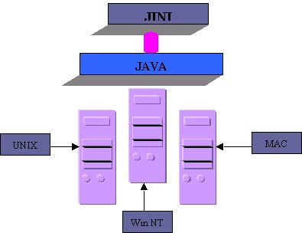

Fig1.Jini as top of Java runs on any OS

The central mechanism of a Jini system is the Lookup service that registers devices and services available on the network. It is also the major point of contact between the system and the users of the system.

When a device is plugged into the network, it locates the lookup service (discovery) and registers (join) its service there. While registering, the device provides a callable interface to access its functionality and attributes those may be useful while querying the lookup from another jini client perspective. Now, the service offered by the device may be located and used by clients on the network. This basically involves discovering lookup, querying it for the specific service and invoking the callable interface of the service required. The callable interfaces are exposed and accessed through Java RMI (Remote Method Invocation). The proxy code that is used to access an interface is stored within the lookup services during registration and downloaded by clients automatically. Thus the need for specialized drivers is eliminated.

Thus Jini allows building up clusters of services that know about one another and cooperate - creating a “federation” of devices. The term federation may be understood to be a collection of co-operating, but autonomous entities. However, with Jini, Java on the devices is almost mandatory, and the interaction mechanisms - the interfaces, the methods, what to call, when to call must be well defined for devices to join a federation that you create. In the next few sections, we try to explain Jini from the perspective of simulating a Printer or Camera service that a Jini federation makes use of.

Discovering a lookup service

Our Printer or Camera service will first have to register itself as a JINI service. To accomplish this, the Printer or Camera should discover a lookup service and register it. There are two ways of discovery, unicast discovery and multicast discovery.

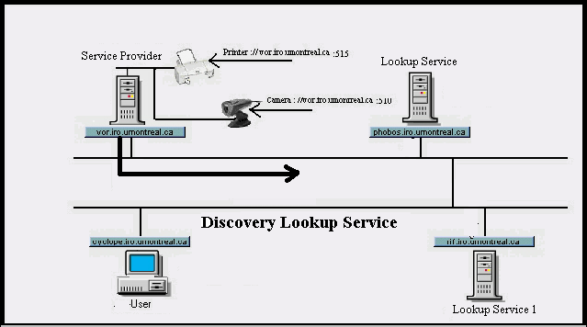 Fig.2 A service provider seeking Jini Lookup Service

Unicast Discovery

For unicast discovery, the device must know the IP address and the port number where the lookup service is running. The device sends a unicast discovery protocol packet to the pre-known IP and port. In response, the lookup service will send a unicast announcement packet to the device after the discovery packet is recognized and accepted.
The rest of the operations on the lookup service can be done through the ServiceRegistrar object. All the Unicast discovery protocol fundamentals are encapsulated within the LookupLocator, so we no need to worry at all.

Multicast Discovery

Multicast discovery is used when the locations of Jini lookup services are not known beforehand. The network must be multicast enabled by configuring the router settings to locate Jini lookup services outside of your network domain.

Multicast is something like a controlled broadcast; the multicast discovery packets can cross gateways and reach designated multicast “groups” of machines. Setting a TTL (Time-to-Live) parameter can control the range of multicast discovery packets. This TTL parameter specifies the number of gateways the packets may cross. By default the TTL value is 15. By sending out multicast discovery packets over a designated network range, a device can detect Jini lookup services running within that range, within specific multicast groups or even all groups if necessary. Once the discovery packets are detected, the lookup services will send multicast announcement packets into the network, which might reach your application that acts as DiscoveryListener.

Note that the device may get responses from more than one Jini lookup service. It is upto the device to decide when and where to register itself.

Joining the Lookup Service

After locating the lookup service, the Printer or Camera service would need to join the lookup service. Join occurs when a service has located a lookup service and wishes to contribute itself. The device first locates the Jini lookup service under a specific group and then registers its service in it by loading its service object. A group identifies and/or organizes the set of services available under a category. For example, printer groups registers print services. The default group is public. However, the present Jini implementation has the drawback that it locates all lookup services pertaining to the specific service, not just public alone. If we request for a specific service, both specific and public lookup services will be found.

Note: Here, we implement the same Printer or Camera service by the name as the registration approach is different.

The approach of the join method here is quite different from that used in the Join Manager case. In this case we explicitly enumerate lookup services on the network, create a ServiceItem that encapsulates our service object and a set of attributes, and register this with each lookup service we are interested in.

Lookup services on the network can be discovered using the LookupServiceFind class as discussed in the discovery section. Simply call its getLocators() method to get return an array of LookupLocator objects, each representing a lookup service on the network.

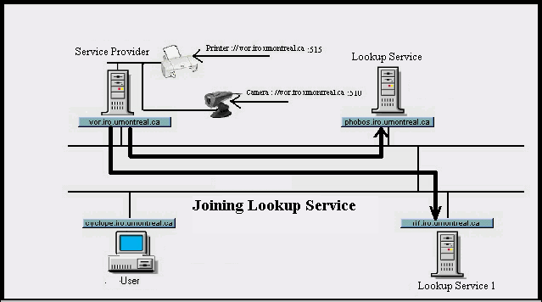
Fig 3 Registering a service with Jini Lookup Service

Note: The attribute set facilitates Service query/Lookup simple and appropriate from a client point of view.

Service Item
Null if this is a new ServiceItem to be registered with the lookup service.
A valid ServiceID that represents an existing service item on the lookup. If you have already registered the service and are now attempting to change some attributes of the service, you have to provide the old ServiceID.
Service Object. The actual service is provided by this object
Service Attributes

Name
Organization
Type
Location
ServiceID

Fig 4 Service Attributes

A Service item is an encapsulation of the actual service object and a set of attributes which
describe the service.

When you register a service with a lookup service, the registration will be available for a certain period only, known as the lease (a returned object from Jini lookup) period. It is a must to renew the lease before it expires. Otherwise the service will be garbage collected automatically. It is also possible to cancel a lease following which the service will be removed from the lookup service. Granting a lease and its duration is fully up to the Lease granter to decide upon.

Looking up and accessing a Jini Service

Lookup involves querying Jini lookup services using a service template. This service template, represented by a ServiceTemplate object, can specify fully or partially an attribute set. This is matched against the attributes of registered services and any matching ServiceItem objects are returned. It is possible to ask for a single matching service or N matching services, as you would choose.

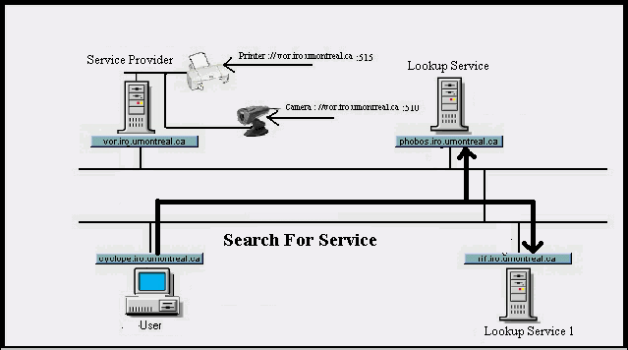
Fig.5 A Client search the Jini Lookup Service for a specific type of service

A Client for the Printer or Camera service

Here we finally create a client class to test and access the JINI service that we have developed and registered with Jini.

// Specify the name of the service you need to search for ("Printer or CameraService");

Now we have access to the Printer or Camera interface. Using this interface, the Printer or Camera GUI is obtained by invoking the function getPrinter or Camera().

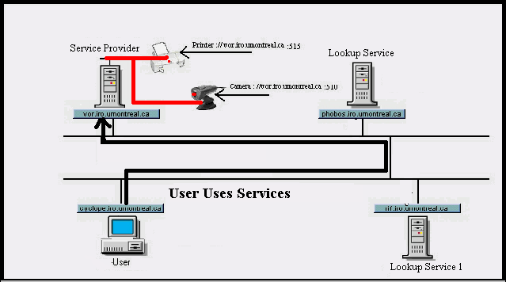

Fig 6 A Jini Client invoking service on the service provider machine

To summarize what we have done so far:

- We located a Lookup Service on the Network

- Registered a Service to it (Printer or CameraSerivce)

- Obtained the Service ( Printer or CameraService) from the Lookup Service

Starting the Animation

The JINI Actors:

- 2 Looup Services: phobos.iro.umontreal.ca and rif.iro.umontreal.ca
- 1 Service Provider: vor.iro.umontreal.ca with 2 services: printer and a camera video
- 1 User: cyclope.iro.umontreal.ca
Buttons, check boxes, lists and text areas:
- Open JINI: Allows the use of all the functionalities of the applet.
- Close JINI: Resets all the functions.
- SP First time: If checked, for the registration of the services the SP must at first discover the LSs with a multicast discovery before the registration, the ‘Deregister service’ is disabled at the first time (SP still doesn’t know the LSs and no services are registered).
- SP Services list: Contains the services to be registered or deregistered by the SP at the LSs.
- Register service: Allows registration of the services.
- Deregister service: Allows deregistration of the services registered.
- Crashed LS: Eliminates the availability of the LSs.(In this case the USER will request the SP).
- Refresh LS: Returns the availability of the LS.
- USER Services List: Contains the services USER will request.
- USER First Time: If checked, the USER discover the LSs and SP before requesting a service on the network.
- Service Available for user: is the list of services discovered by the user. Double click on the service will release its use.
- Speed: Indicates the level of the speed of the ball.
- Media: is the sound status, ON or OFF. Each action of the program has its own sound.
- Help: shows the Help window on the Service Location Protocol and the applet guide.
Service Agent, User Agent, Directory Agent and Directory Agent1 text areas: show each status of the actors when an action is executed.
Messages Description: Contains the structure of each message sent and received.
vor.iro.umontreal.ca, phobos.umontreal.ca, cyclope.umontreal.ca and rif.umontreal.ca buttons will release the requested action ( Service register, Service Deregister, Service Request, LS Advertisement, SP Advertisement)

Actions :
In the JINI Simulation, we want to see how a user (User Agent) can get a simple reply to his question: " Where can I find a printer and a Camera available in the scope department INF.
The process of this request is split in different actions:
Services Registration:

At the beginning the operator can chose the status of the SP if its request is for the first time.
- If ‘first time’ flag is checked the program pass in the following steps:
- SP multicasts a LS Discovery by the Service Request (Service: Directory Agent)
- LSs reply by LS advertisement
- SP sends Service Register for the service chosen by the user
- LSs unicast to the SP a LS Acknowledgment
With these actions the LSs are discovered by the Service Agent and the services are registered at the LSs.
- If the ‘first time’ flag is not checked:
- SP sends Service Register to LS for the service chosen by the user ( Figure 3.)
- LSs unicast to the SP a LS Acknowledgment

Service deregistration :

The service deregistration can be accomplished in a condition that we have already registered services
- SP send Service Deregister to LS for the service: Printer or Camera.
- LSs unicast to the SP a LS Acknowledgment. Afterward LS send a LS Advertisement.
PS: The services registered or deleted will respectively appear or diSPppear from the ‘Active service list’. We can choose the service we need to use from this list. (USER will use the services appearing in this list)

Service Request :

In order to use the services by the USER
· If ‘first time’ flag is checked the program pass in the following steps:
- USER multicast a Service Request (Service: Directory Agent)
- LSs reply by LS advertisement (USER is configured by the SCOPE=INF then it will use the LS with the SPme scope in this case it’s Phobos)
- USER unicast to the LS (Phobos) a Service Request for a desired service (ex. printer).
- LS unicast to the USER a service reply with the addresses of the available printers
- USER unicasts to the LS an Attribute request for more information on the services
- LS unicasts to the LS an Attribute reply with the requested information.
- If the ‘first time’ flag is not checked all the steps mentioned above will be executed without the first two steps.
After the execution of these steps the program shows the printer or the camera are working (Animated) and used by the USER.

LS crashed :
- USER unicasts to the LS a Service Request for a desired service, but LS doesn’t respond
- SER multicast a Service request (service : Directory Agent),but LS does not respond
- USER multicast a Service request (service : Service Agent)
- SP multicast SP Advertisement
USER will unicast its services to the SP
Afterward all the services will be requested from the SP till USER receive a LS advertisement.
We can set the media on or off. Each action of the program has her own sound.
We Can reset the applet by the ‘CLOSE JINI’ button.

Difficulties faced and resolved

Every project has its own difficulties, in this one we faced some, but we could resolve them:
- The JINI is a new Protocol the documentation is not very wide on it.
- The synchronization for the buttons and checkboxes.
- Explanation of the multicast and unicast on each station
- For one action we implemented all the possibilities that exists on each station
- We implemented every structure of all the messages sent and received between User SP and LSs.
- Access to the help from the Applet itself.
- Two kinds of help, one for the applet and one for the JINI explanation
- Each action release the transmission of defferent packets at the same time that made a problem for the animation.
- For the help files we faced some problems on the images drawing.
- Many tests on the project were executed to be sure that the applet is running perfectly
- To have a very clear and comprehensive program, we must have a very good planning and analysis. In this simulation we had some difficulties to cover all the aspects of the JINI, but we succeeded after a profound analysis.

Conclusion

It’s not easy to cover all the functionalities of the JINI Technology, and showing all the structures of the packets sent or received each time.
In this simulation we succeeded to show all the functionalities of the JINI Technology in a clear and comprehensive way, with the help of the animation.
Jini Technology is a simple, lightweight protocol for automatic maintenance and advertisement of intranet services. It defines entities known as User , Service Provider, and Lookup Service, and defines the protocol operations between them. JINI offers an easily understood model of service operations, and relieves system administrators of the need to configure service information in most new user installations. Taking services offline for routine maintenance, or bringing them back online, can occur with no reconfiguration needed on user machines. Installing new services is as easy as filling out a form. Services may also be enhanced to allow them to automatically register with JINI, so that no administrative intervention is reauired at all, beyond activating the Service Agent. Designing and debugging new services is also supported inherently by the design of the service namespace. It is our belief that JINI is the best choice for future management of networked services, and that this superiority will continue to widen as the world of computing increasingly becomes the world of access to network services and resources.

